Without Base condition:

It will let to infinite times.

With base condition:

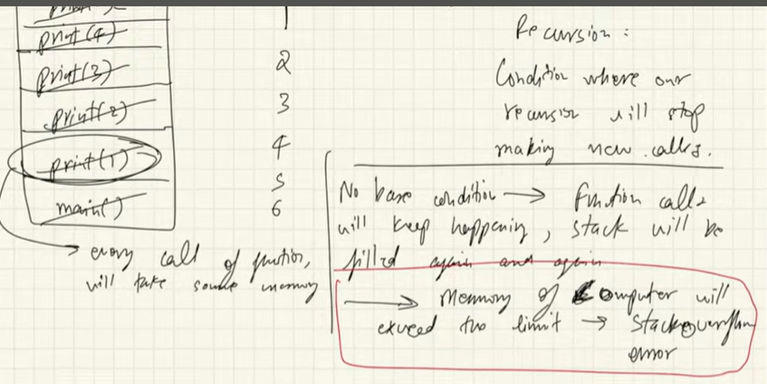

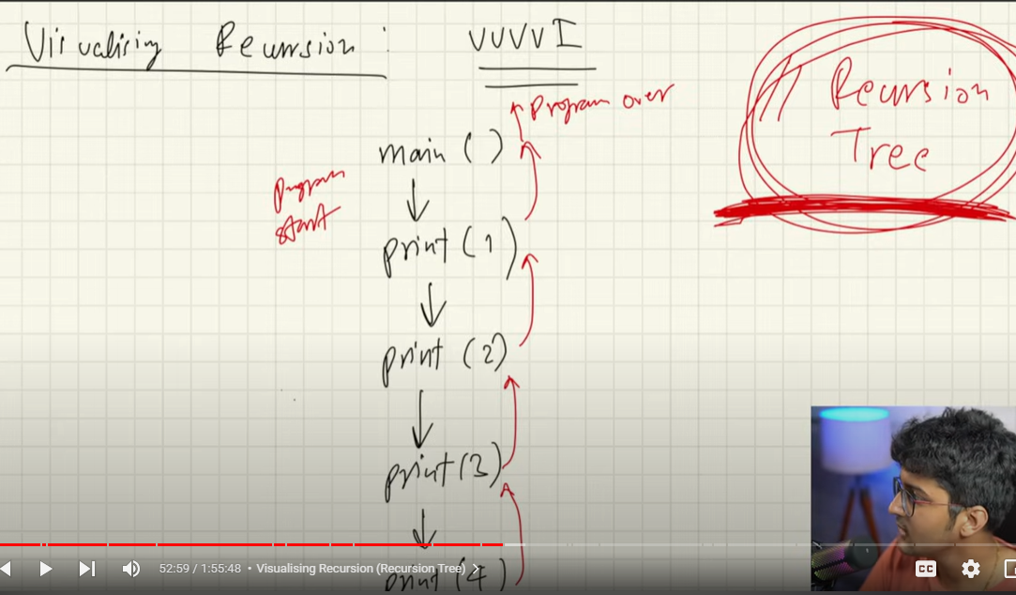

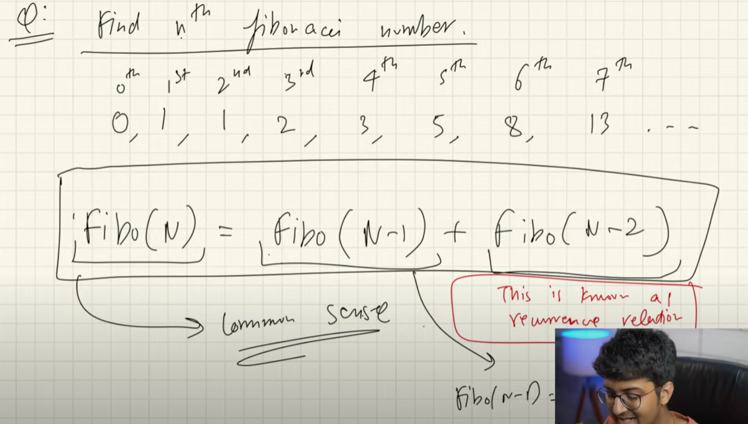

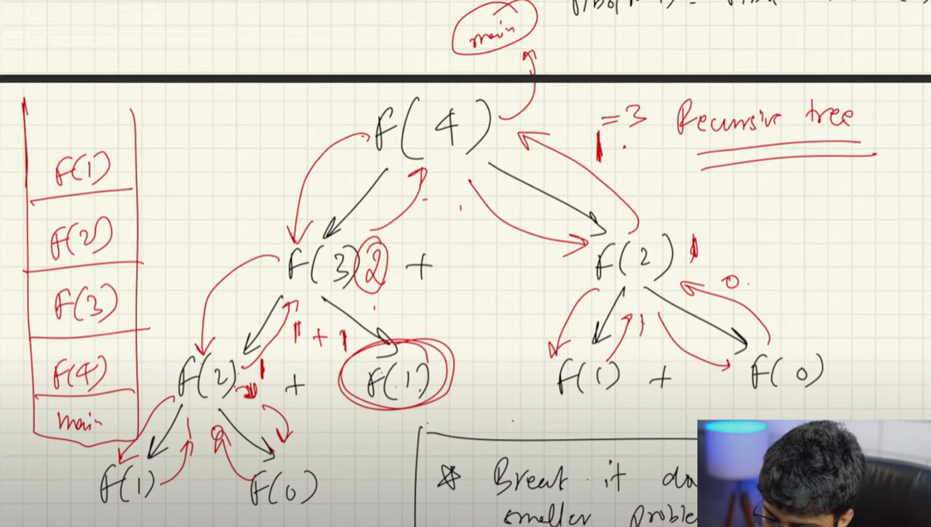

The above fibo is not tail recursion because of last return has two functions.

Approaches for recursion:

